**CREATEING A MULTIBOOT USB DRIVE BY SIMPLY COPYING ISO IMAGES TO IT**

**STEP 1: Download Ventoy from** [**https://www.ventoy.net/en/download.html**](https://www.ventoy.net/en/download.html)

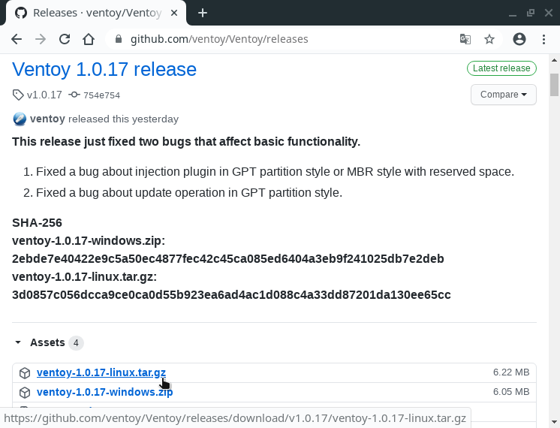

**STEP 2: Mount pendrive**

**STEP 3: Open ventoy folder and open ventoyDisk2.exe file**

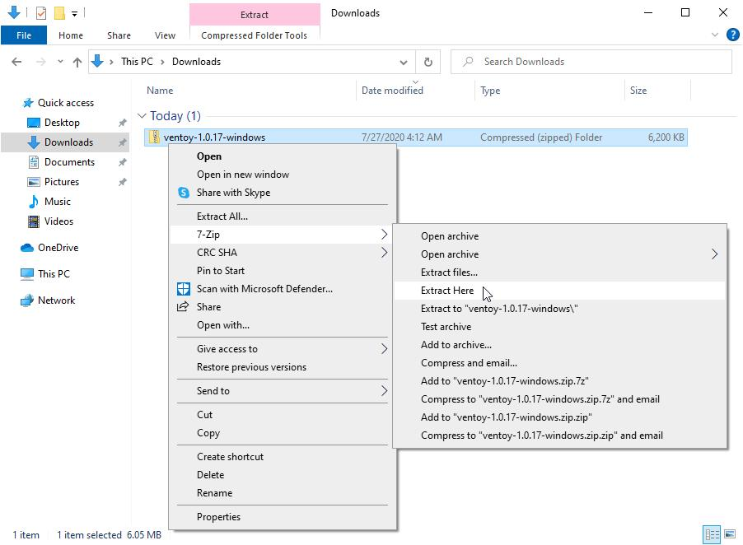

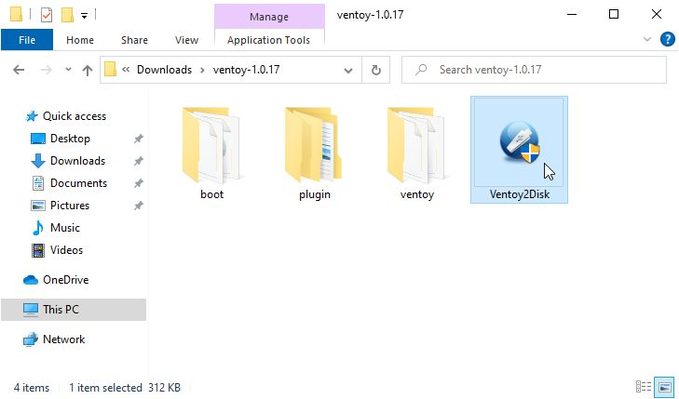

**STEP 4: Select the device that should be converted as a bootable device and click the install button**

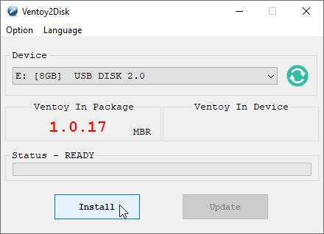

**STEP 5: Double check you are formatting the right device and click Yes**

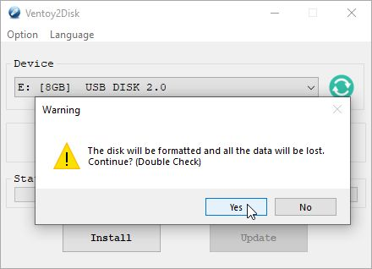

**STEP 6: When the installation process is completed the device will be converted into a bootable device**

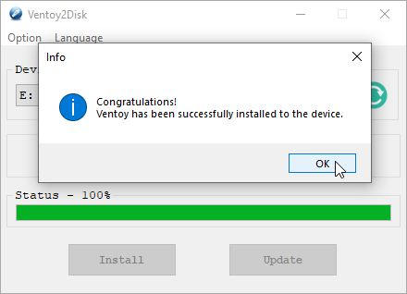

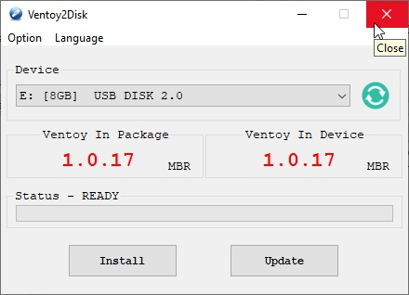

**STEP 7: Copy the iso file to the newly created bootable device**

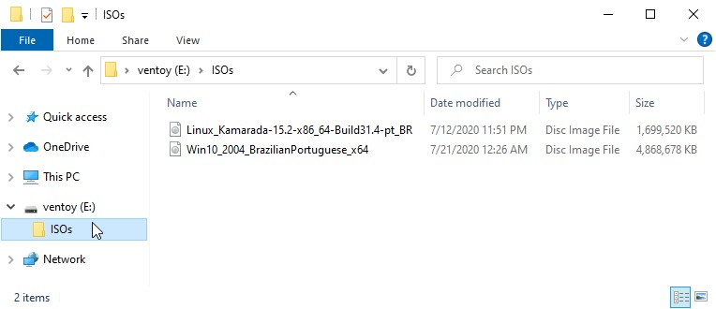

**STEP 8: The device is now ready**

**ADVANTAGE OF USING VENTOY**

* **Multiple iso(such as Linux , Windows etc..) can be copied to the newly created bootable device**